 Mob Apps FC 1st Asn Feb-2013 “Speed” 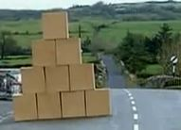
Jonathan O'Brien/MobAppsFC/jonathan.obrien@mycit.ie

Class Diagram

The Splash Class is the Entry point to the Application; it is set as the launcher. It uses a Graphics view object to draw the name of the App to a canvas. It only displays for 3000 milliseconds and then uses an Intent to call the Mainscreen activity class, which is the class which takes in user input for calculations, displays previous results, has an implicit intent to call an Email app, and also packages and sends the user input to the Comp Activity class for calculation. This in turn creates an object of the calculation class an passes it these values, this is used for the actual calculations. The Comp class also displays results in Dialog popups and has a pending intent for a website.
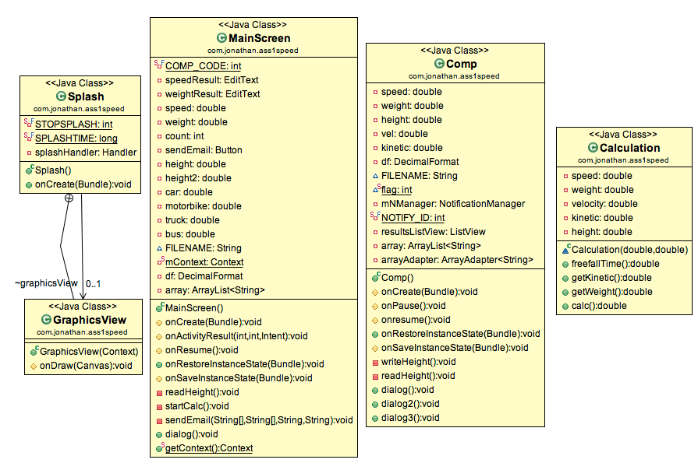

1 (a)

TextView, EditText and Button components in the main activity page in portrait mode. Use one LinearLayout inside another. Any text relevant to the components should be stored in the strings.xml. A Second horizontal layout that is slightly different to the portrait one.

Completed? Yes

XML for TextView that displays app name on the top of the activity screen in Red; and one of the EditText views for taking speed input from the user. Text that is relevant to components is stored in strings.xml.

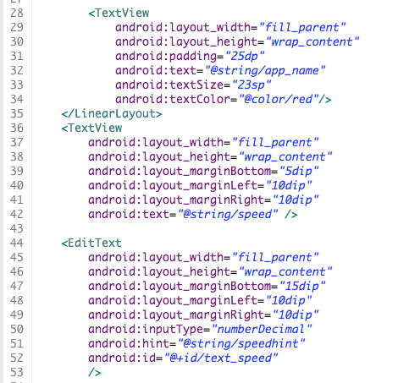

Code for EditText that takes input from the user in the form of a double, catches if the user inputs a null value. It stores the data when the user hits the enter key on the Virtual keyboard. It also displays a toast confirmation message to the user stating what value that they have input.

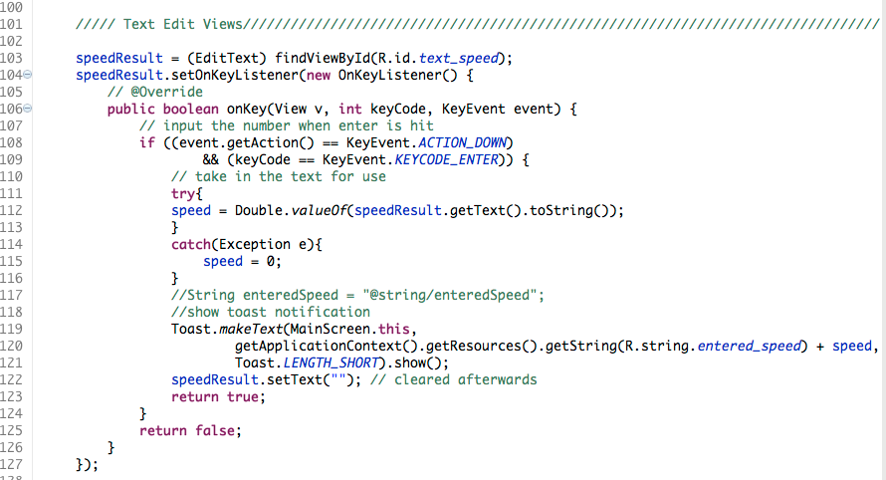
Buttons that start different methods, in this case a button, which starts the calculation by initiating another Activity, and another button that displays previous results from the last calculation preformed.

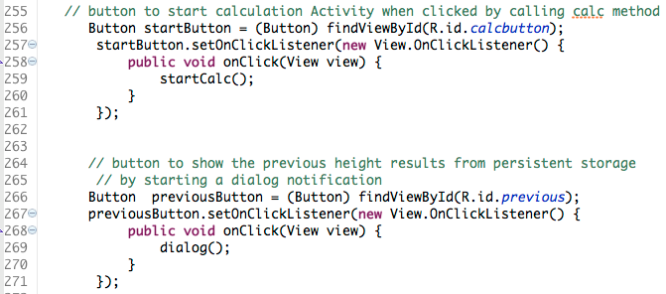

Portrait view

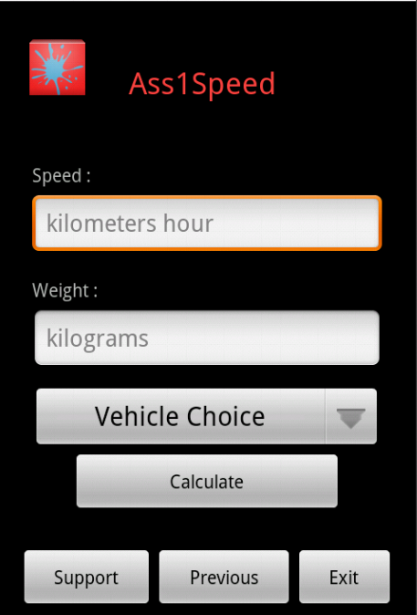

LandScape View

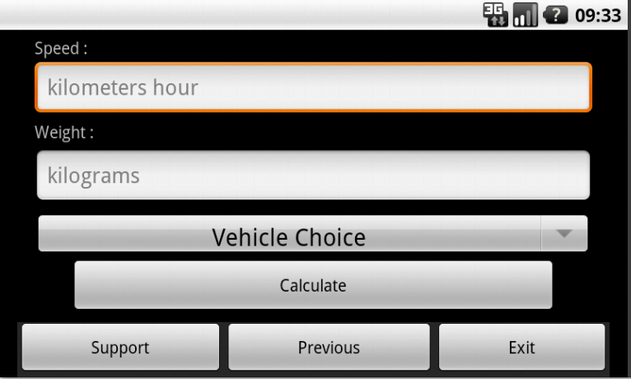

There are Three Linear layouts for this activity the screenshot below displays the start of too of them.
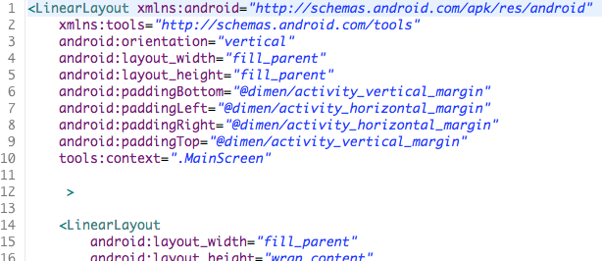

1 (b)

Create your own App icon in 3 different resolutions (doesn’t need to be beautiful!)

Completed? Yes

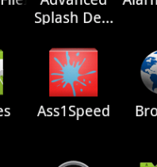
1 (c)

A trigger on the first screen (Activity) launches a second screen and passes data to it for display. One of the 2 Activities displays the calculated free-fall distance. A trigger on one of the screens launches another component on the device e.g. a web page, phone call etc.

Completed? Yes

Method called by button to start Comp Activity, creating an intent that stores the speed and weight values to be passed. The Comp activity then displays the calculated free fall distance.

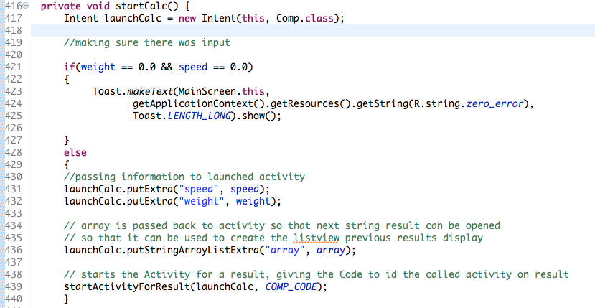
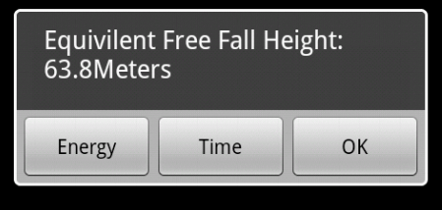

An implicit intent, which starts an email application on the phone. Passing values such as email address, subject, and etcetera.

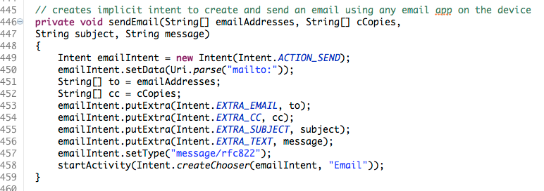

1 (d)

Localize your App for a second language of your choice. Include the App name. Change the language in your AVD to see your App correctly & automatically switch to and from the second language.

Completed? Yes

Application localized to french

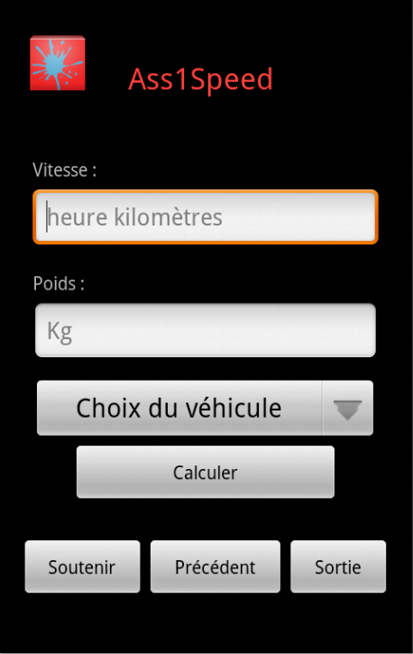

1 (e)

Use 3 alerts: Toast, Dialog & notification.

Completed? Yes

Toast popup for confirming user input into Edittext.

Dialog display for Previous result displayed on the MainScreen Activity, activated by a button component.

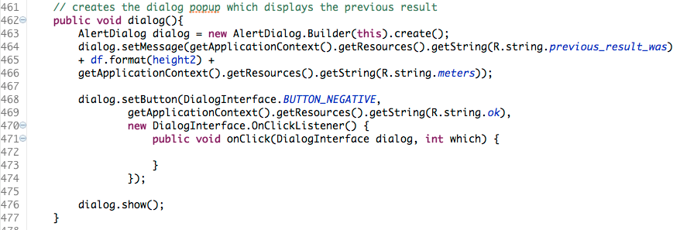

Notification activated by a button on the Comp activity. Calling a webpage.

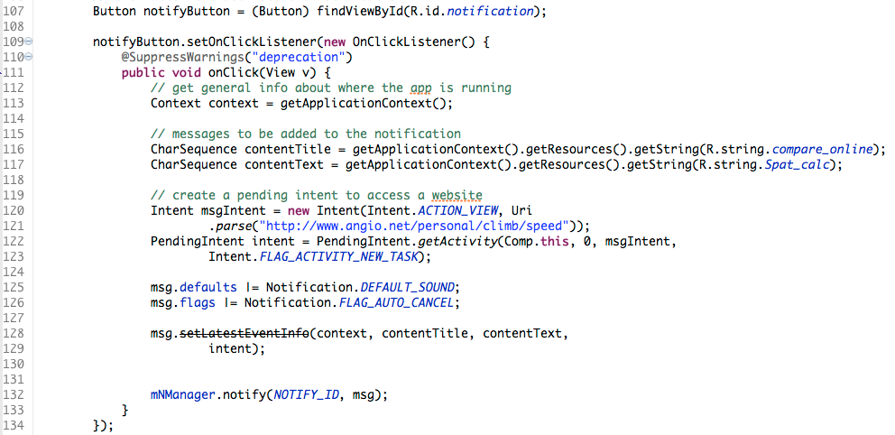

2 (f)

A pending intent for (e) above

Completed? Yes

Pending intent for (e) notification.

2 (g)

Save the App state so when quitting the last speed is saved. Restore on re-launch.

Completed? Yes

Saves state of the Comp activity, one using the onpause() method and OnResume() to store the height to a file. The other utilizing the onSaveInstanceState method for orientation changes.

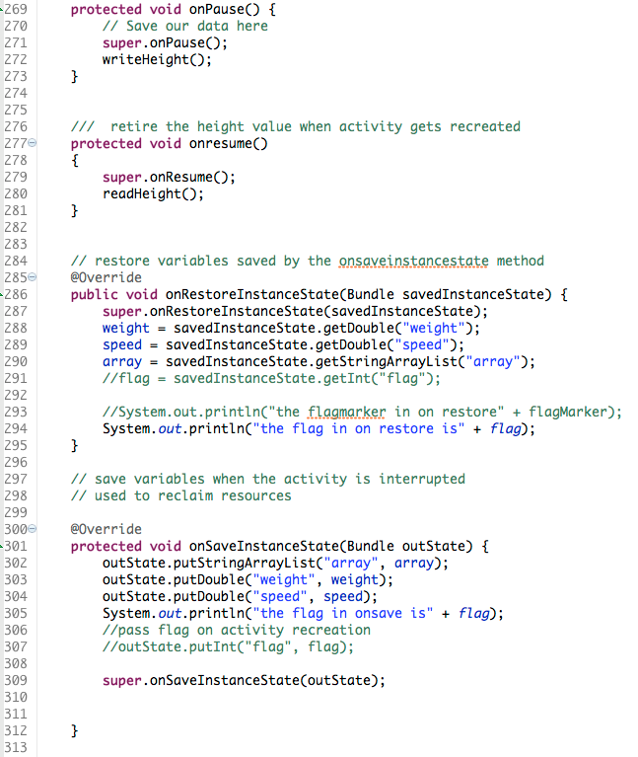

Stores the height variable to a file when onpause is called.

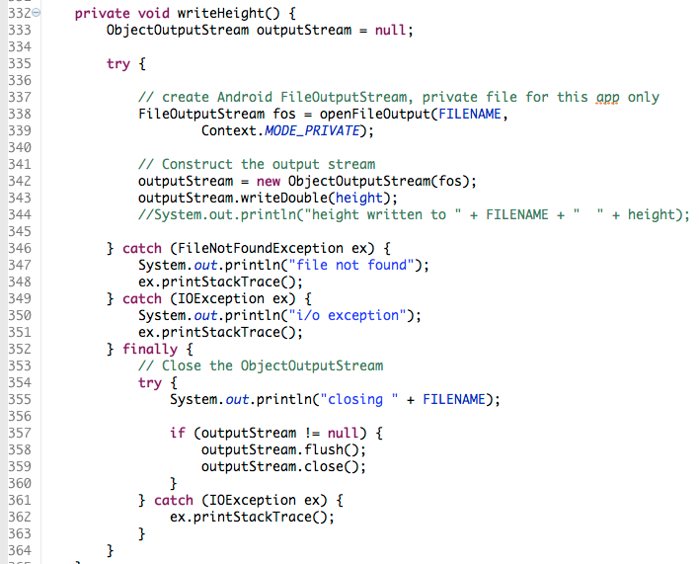

Reads back in the height variable from the file.

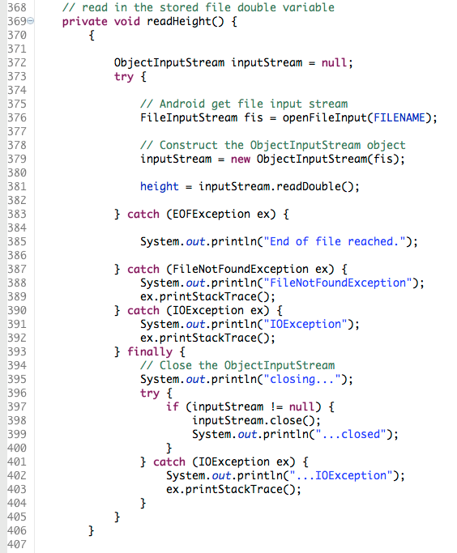

2 (g)

Draw a graphic to display some app related info.

Completed? Yes

Draws the assignment name and some other text to a canvas when the application is launched, this is in the Splash Activity which is displayed for 3000 milliseconds before the main Activity is launched.

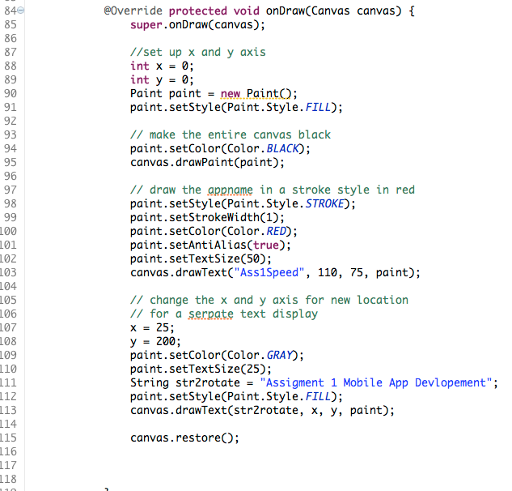

2 (h)

Others,

Completed? Yes

Spinner Component.

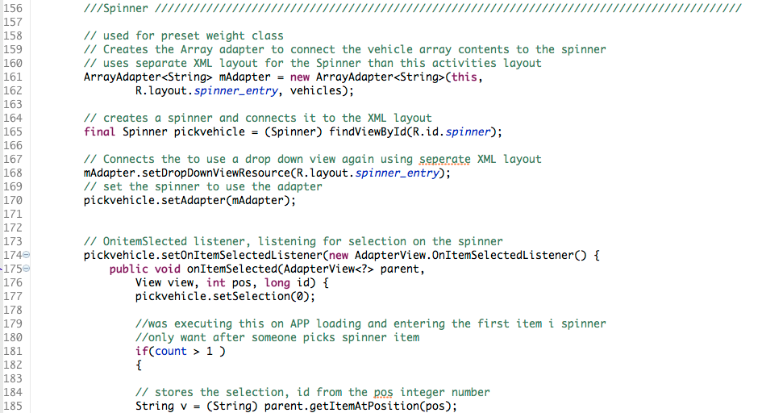

A ListView that is populated by an Arraylist with an adapter. This shows the previous results generated by the App. Each result appended to the array list when created.
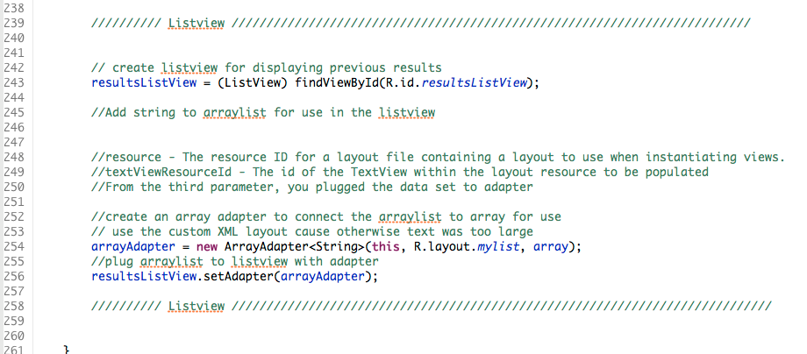

Evaluation
Since I have had no experience with GUI based programming before I took the approach of creating a Template for the main App activity first, I estimated what components that I would be using and attempted to leave wiggle room for more if necessary. This worked out all right in the end, but would have been far better if I had planned each out individually, figuring out which components would be used before creating the GUI, and designing accordingly. This will be more likely for the next assignment as I now have a better idea of what the components of android are and function.

I have a pending notification added to the Assignment, but only activated by a button. Requiring user interaction to initiate. It would have been better to have an application event to initiate the notification automatically.

I added the splash screen at the end; I would have liked to have added an animated screen, with a progress indicator. Or even have better graphics generated.

The Listview is updated from an array, this array is passed back and forth between activities, it would have been far better to have this stored into device storage and retrieved again when needed.
I could also not figure out why I required a Static integer to store the flag indicating that the restoreinstnacestate method was called. It would get reset to zero; the declaration of the class perhaps was causing this, but totally unsure.

I would also design the interface to be more user intuitive as its not in its current state, with the spinner for vehicle selection being possible confusing to the user, as its not obvious that it is an optional setting over the weight entry.

Where possible in future I would like to create more classes to separate the code out a bit more to be more readable.

